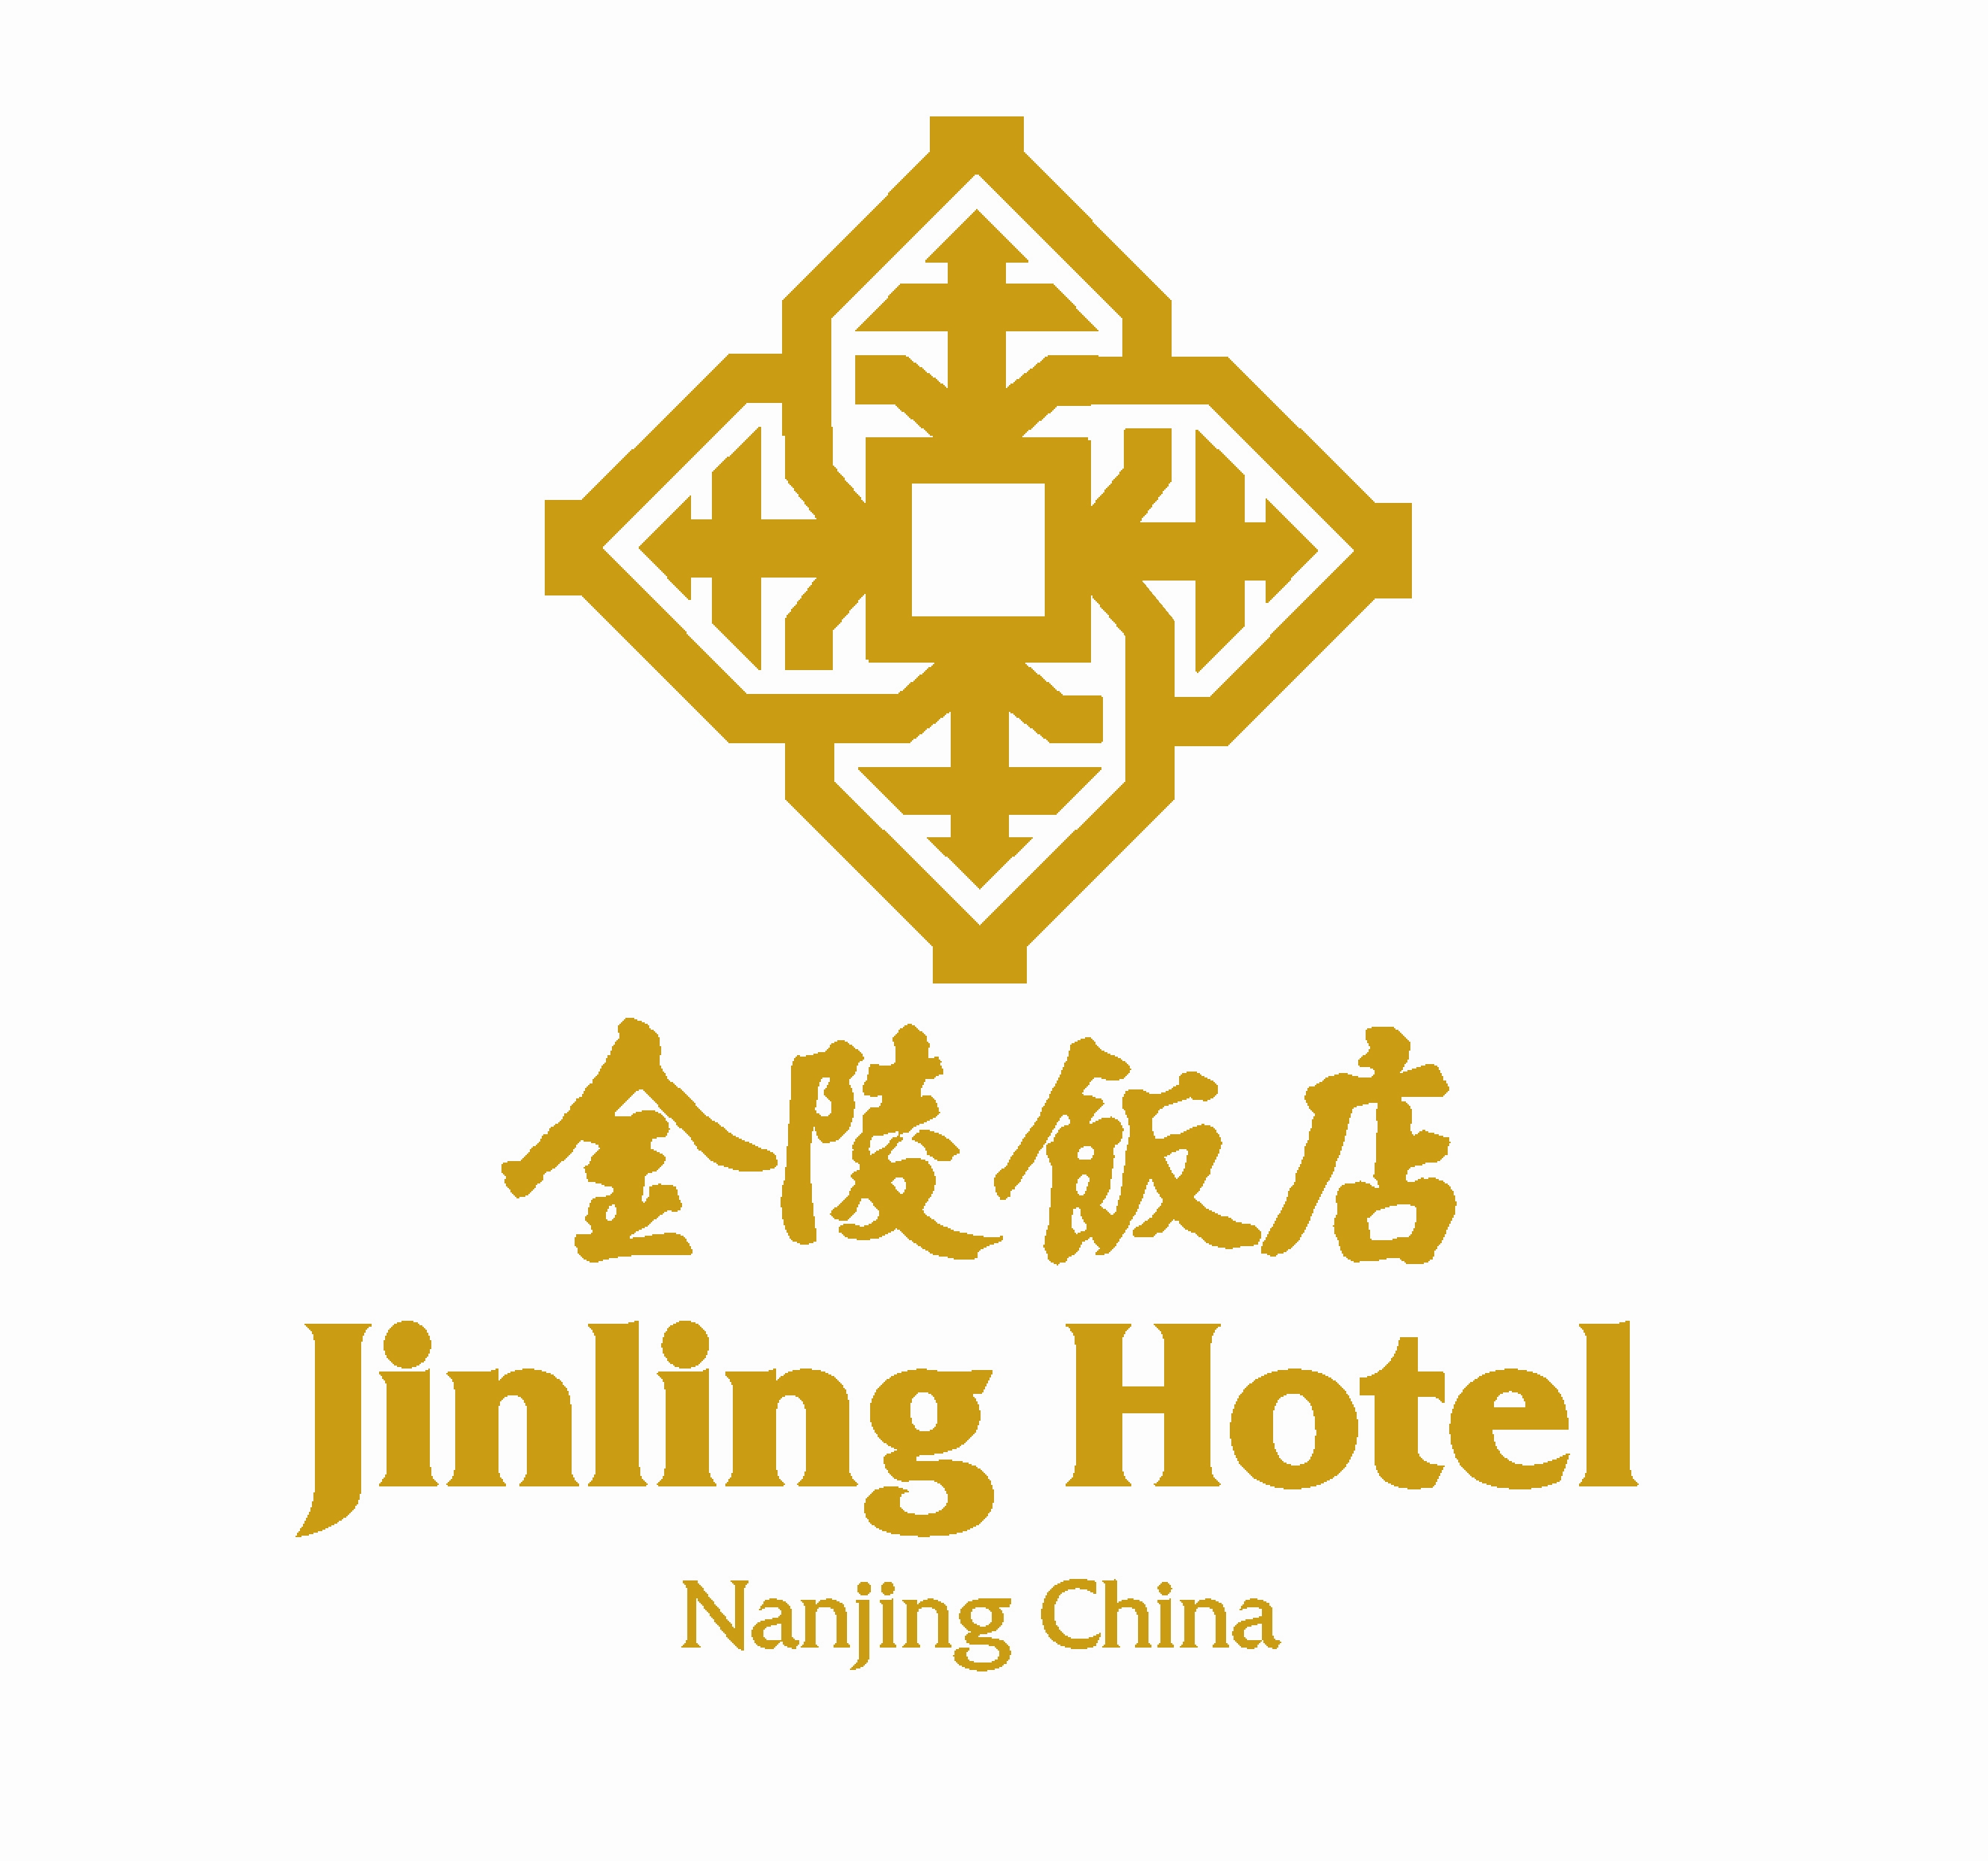
The 8th International Symposium on Cement & Concrete
Confirmation Number (CON13044)
Address: | 2# Hanzhong Road, Xinjiekou Square, Nanjing 210005,China
Tel: | +86（0）25 8471 1888 （Reservation Department）
Fax: | +86（0）25 8470 4141
E-mail: | crs@jinlinghotels.com

We are pleased to confirm the following reservation(s)::
Sex: |  | Male Female
Family Name: |  |  |  | Given Name:
Arrival Date: |  |  |  | Departure Date
Credit Card Info. |  | Card Number： Expiration：
Contact Info. |  | Tel: |  | Fax:
 |  | E-mail:
Please choose the Room Type with“X”
 | Room Type |  |  |  | Room Rate per night
 | Superior |  | Jinling Hotel  ★★★★★ |  | CNY 680
 | Deluxe |  |  |  | CNY 768
 | Jinling Deluxe |  |  |  | CNY 878
 | Executive |  |  |  | CNY 1178
Non- smoking Smoking Single Twin
If you need transportation to or from airport/railway station, please advise us so that we can make your reservation. The following rates apply: Yes No
Lukou International Airport Nanjing Railway Station Nanjing South Railway Station
Buick RMB450 RMB250 RMB300

Hotel Limousine
Deluxe limousine service is available for a charge. | Picking up |  | Sending off

Date: |  |  |  | Model: |  | Price:

Important:
- Rates are quoted per room per night and are subject to 15% surcharge
- One or two complimentary buffet breakfast and free internet (broadband & wireless) access are included in the rates. Extra breakfast costs CNY 98 per person.
- Rooms will be held until 18:00 unless the booking is guaranteed with credit card. Please contact with us if there is any change in your booking in order to avoid any No-show charge.
- Standard check-in time is 14:00; check out time is 12:00 noon.
- Any questions, please contact with hotel Sales Manager Ms Frances Fang at frances.fang@jinlinghotel.com

www.jinlinghotels.com crs@jinlinghotels.com
Tel: (86-25) 84711888 Fax: (86-25) 84711666
Xin Jie Kou Square, Nanjing 210005, China

